What Do You Know About Guide Dogs?
Module 3 Guide Dogs
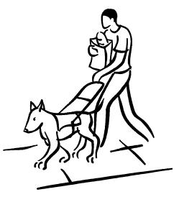

Read through the information on the website http://www.abwa.asn.au/index.html and answer the quiz questions below.

The First Guide Dogs

 Guide dogs were first used to guide the blind in what year? _________

Who found the Institute for the Blind in Vienna at that time?
______________________________________________________________

A school was started to train dogs and it only received international attention 100 years later after the First World War. Why did it become more popular?

______________________________________________________________

A man named Dr Cook brought the first guide dog to Australia. What was that dogs name? ___________________________________________________

Australia’s first guide dog centre opened in which city?__________________

Breeds

 Why are Labradors chosen as Australia’s Guide Dogs?

1.____________________________________________________________2.____________________________________________________________3.____________________________________________________________4.____________________________________________________________

How many puppies are bred every year?_____________________________

How many puppies are born in a litter?_______________________________

When does a puppy leave its mother to commence training? _____________

Puppy Raising
 A puppy is placed within a family to learn socialisation. Often these families have children. Why do you think the puppies are placed in families with children? ____________________________________________________________________________________________________________________________

The puppy raisers teach the puppy new skills. What are some of these skills?

____________________________________________________________________________________________________________________________

Part of the training involves socialisation. Where do the puppy raisers take the puppy to help it learn socialisation? ____________________________________________________________________________________________________________________________

How old is a puppy when it is assessed for its suitability as a guide dog?
______________________________________________________________

What happens to dogs that are seen as unsuitable?
______________________________________________________________

How long does a new guide dog work with a trainer and its new owner?
______________________________________________________________

The Working Life of a Guide Dog
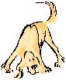

Guide Dogs are trained to do many jobs during their working time. What are some of the jobs they are required to do?_____________________________________________________________________________________________________________________________________________________________________________________________________________________________________________________

How does a guide dog know it is on duty?_____________________________

How old are guide dogs when they retire?_____________________________

© 2007 Association for the Blind of Western Australia
Exceptions: Images
© Microsoft Office Clip Art 2007

